##### --------------------- IR SENSOR-----------------------

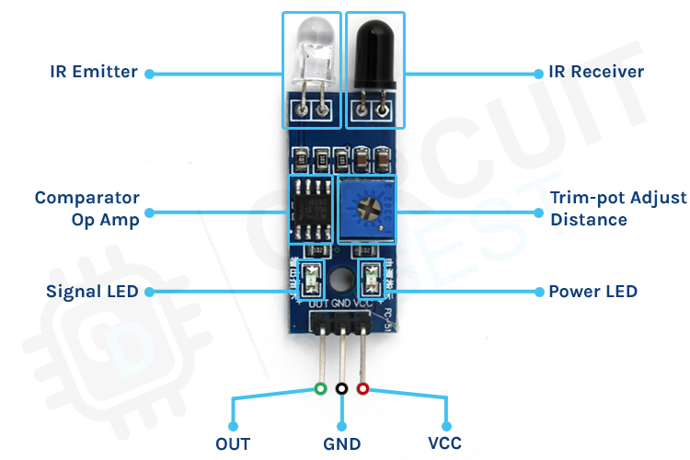

* What is an IR Sensor?

An **IR (Infrared) sensor** is an electronic device

That detects and Measures infrared

Radiation (heat) from objects in its field of view.

It can be used for a variety of applications,

Including motion detection

Temperature sensing, and proximity sensing.

* Working Of An IR Sensor

An Infrared (IR) sensor works by detecting infrared radiation emitted or reflected by objects. It typically consists of an IR transmitter (such as an LED) and an IR receiver (such as a photodiode or phototransistor). The transmitter emits infrared light, which, when it encounters an object, is either absorbed or reflected. The receiver detects the reflected infrared light and converts it into an electrical signal. The intensity of the received signal depends on the object's distance and surface properties. IR sensors are commonly used for proximity sensing, object detection, motion detection, and communication applications, such as in remote controls and automation systems. Some IR sensors use active detection, where they emit and detect their own infrared signals, while others rely on passive detection, sensing only ambient infrared radiation from objects or living beings.

* Circuit of an IR sensor

Refer the below images

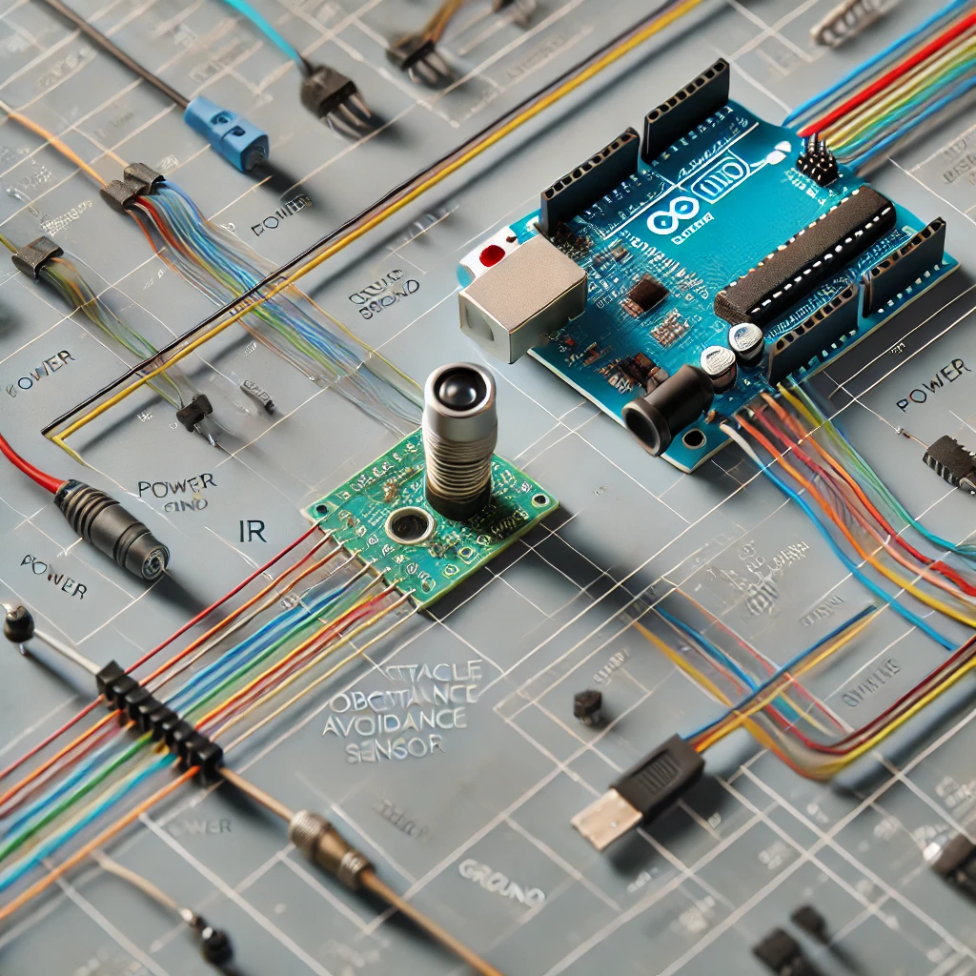

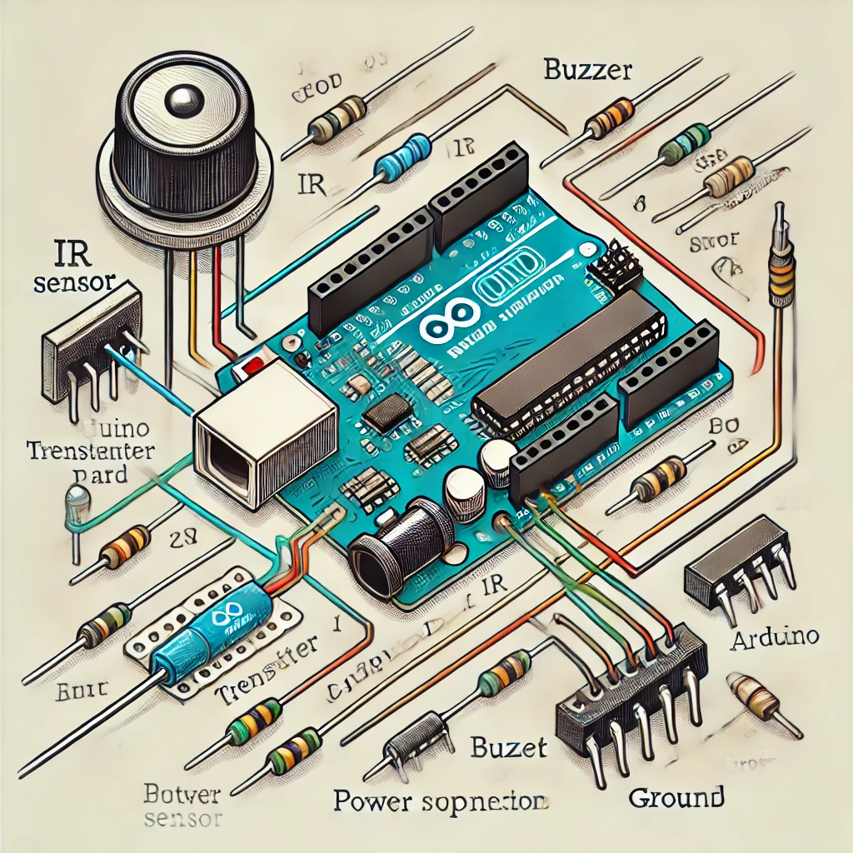

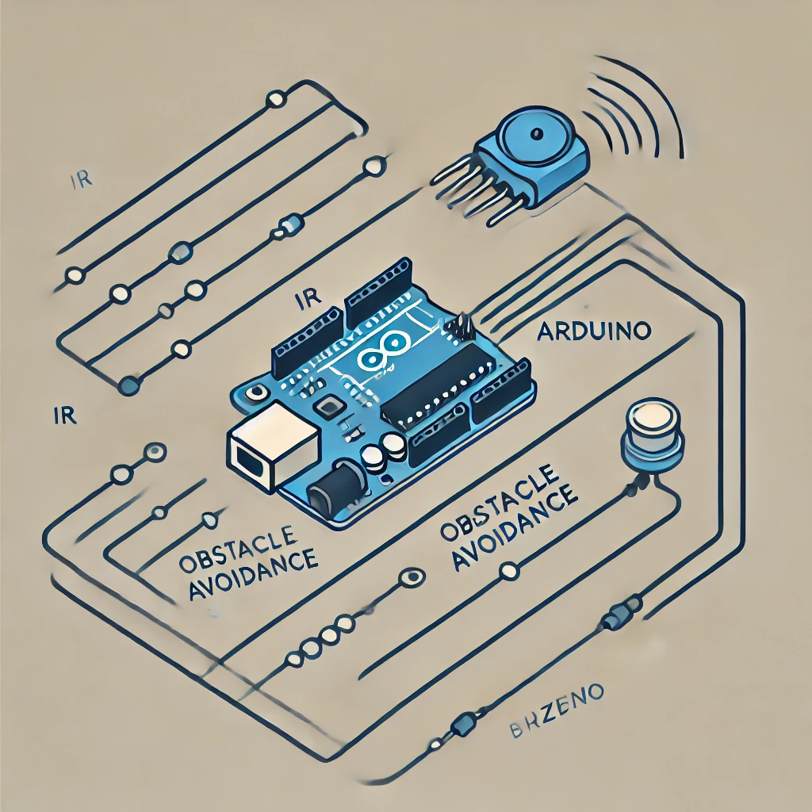

* The Project : Smart Stick for Visually impaired individual

A project designed for blind individuals using an Arduino, IR sensor, and buzzer helps detect nearby obstacles and alert the user through sound. The IR sensor continuously emits infrared light, and when an obstacle comes within 1 cm, the reflected light is detected by the receiver. The Arduino processes this signal and immediately activates the buzzer, producing a sound to warn the user of the obstacle ahead. This simple yet effective system enhances mobility and safety for visually impaired individuals by providing real-time feedback about their surroundings. The setup is compact, cost-effective, and can be integrated into a walking stick or wearable device for practical use.